Q1.

def pangram(sentence):
sentence = sentence.lower()
letters = set("abcdefghijklmnopqrstuvwxyz")
if letters.issubset(sentence):
print("Pangram")
else:
print("Not a Pangram")

pangram("The quick brown fox jumps over the lazy dog")

Output:
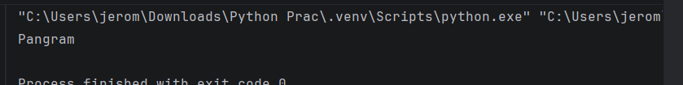

Q2.
num=1234
sum=0

while num > 0 :
digit=num%10
sum+=digit
num=num//10
print(sum)
Output:
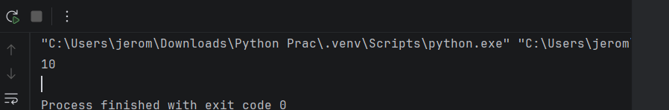

Q3.
lst=[23,6,90]

lst.sort()

print(lst)

Output:

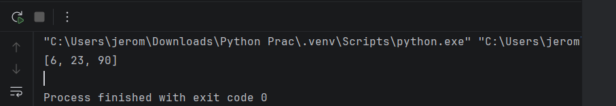

Q4.
num=int(input("Enter a number:"))

divisor=[int(num%i) for i in range(1,num)]
print(divisor)
if num==sum(divisor)/2:
print("Perfect Number")

Output:

